**Screen Shot of the Application**

**1. Starting Server**:  
The Server started with initializing the list of registered users saved in the file.

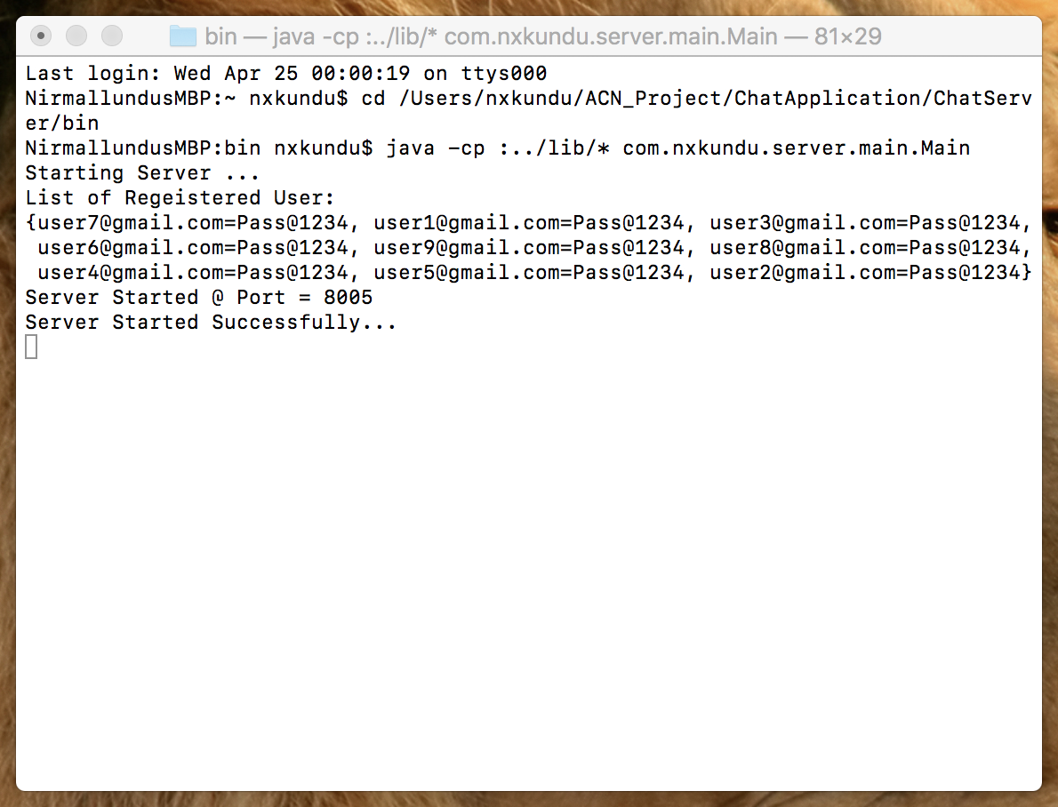

**2. Starting Client**:

Starting the Client shows Up the Login/Signup Screen – For the first time users to Sign-up and the Returning users to Login.

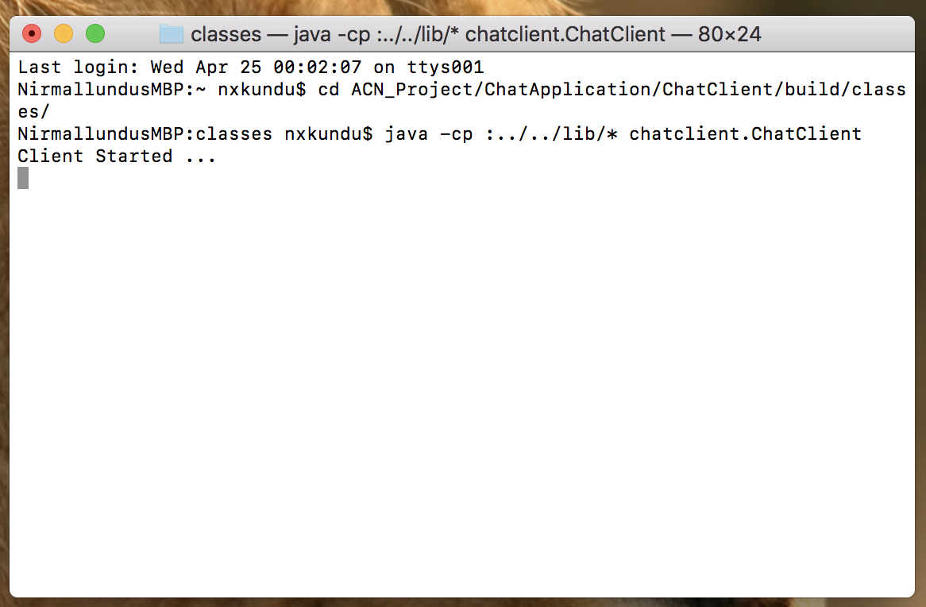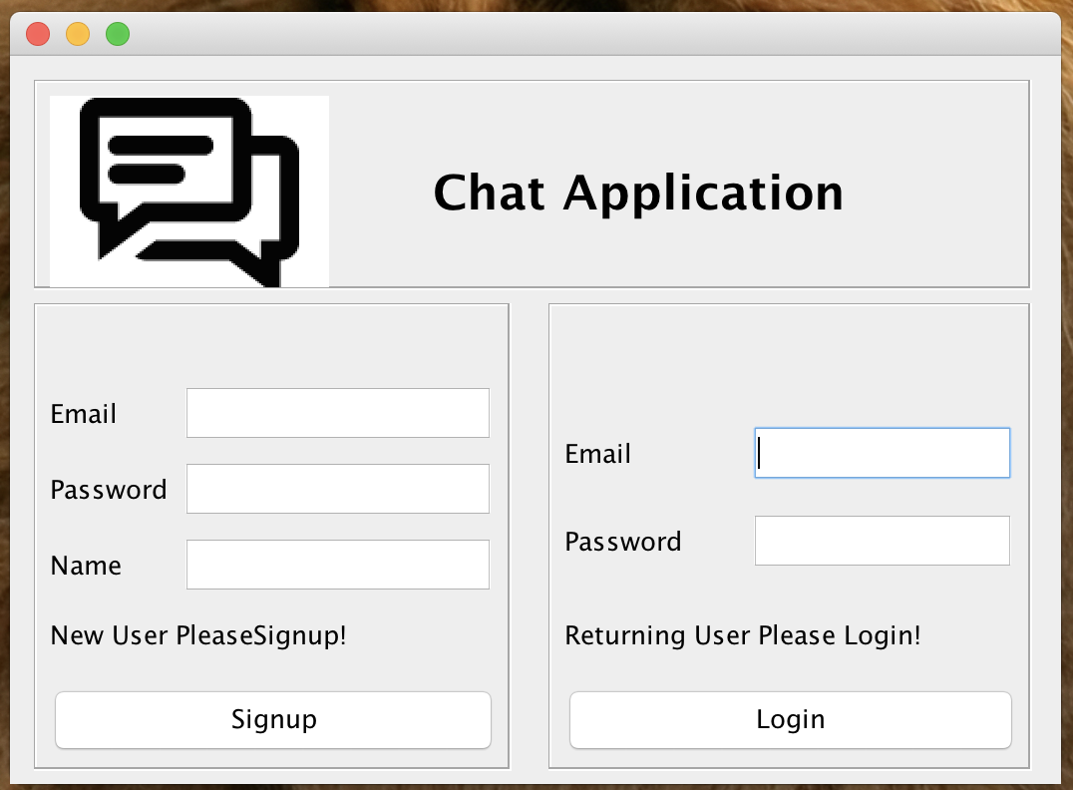

**3. User Signup:**

This screen allows the user to Signup if the signup email does not exist in the system.

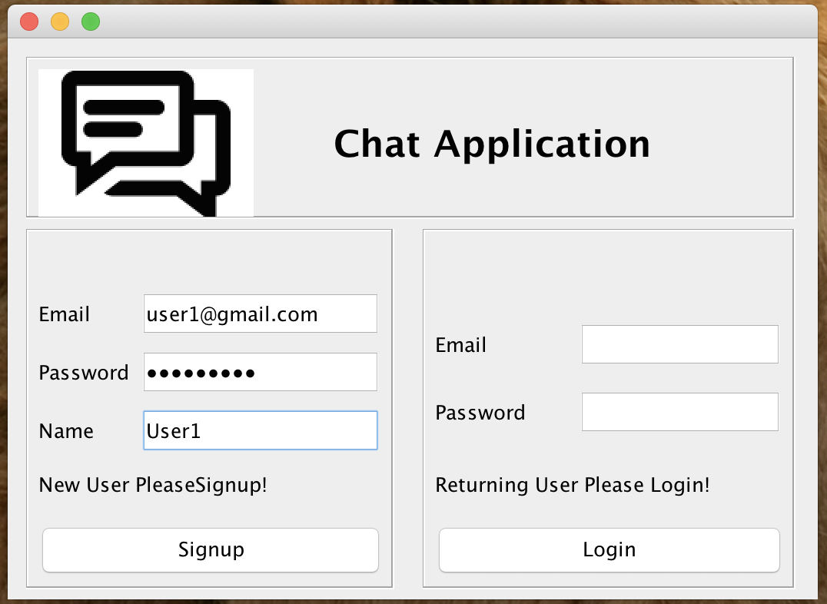

**4. User Login:**

This screen allows the user the Login with Email and Password.

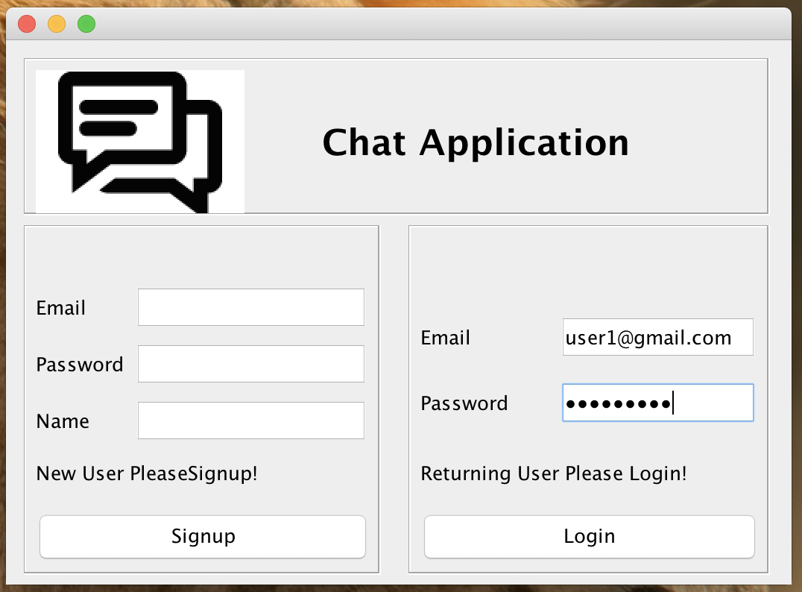

**5. Two Users Logged In**

After successful Authentication the user is taken to the chat Screen which has –

1. List of ONLINE users
2. List of OFFLINE users
3. The Chat History with all users
4. Allow BROADCAST message to send to all users

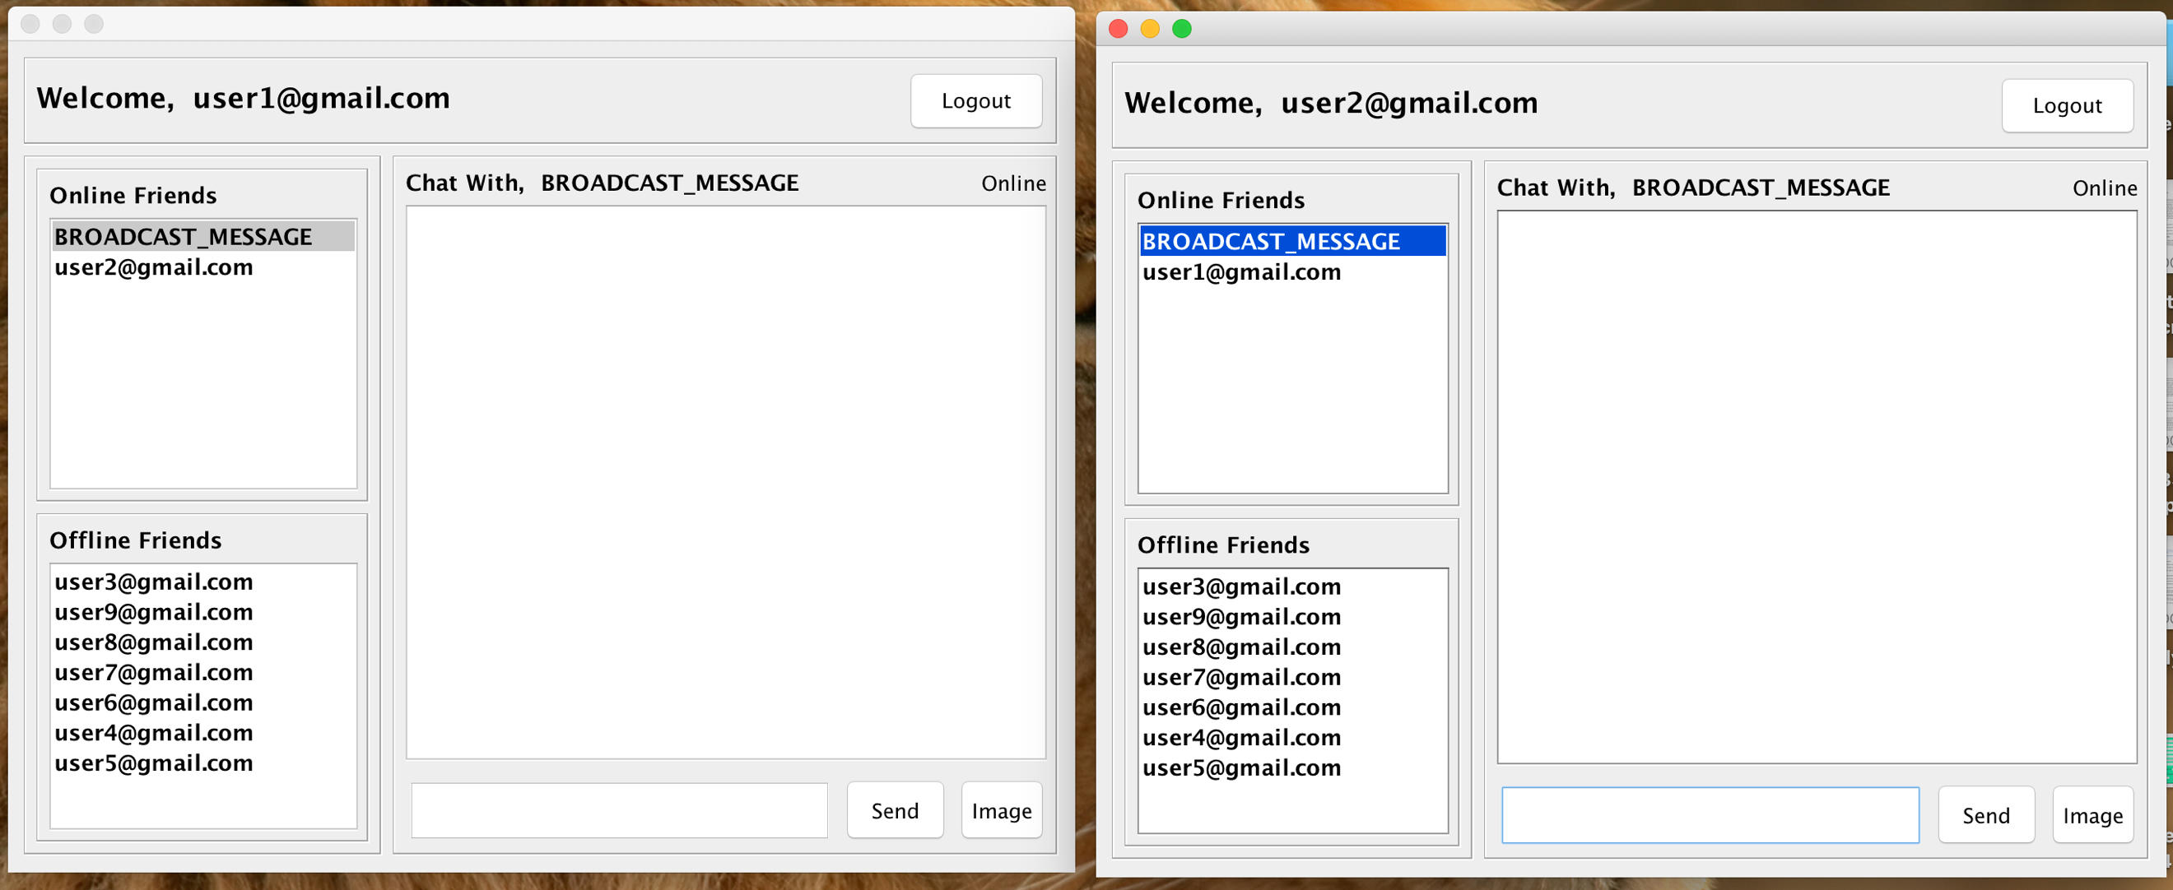

**6. Two More Users Logged In**

As a total four users are logged in now, all the above 4 points mentioned above are updated now.

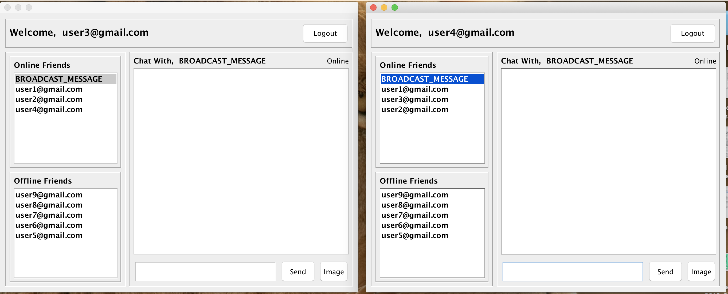

**7. Personal Chat Text Message**

Personal Chat between User1 and User2

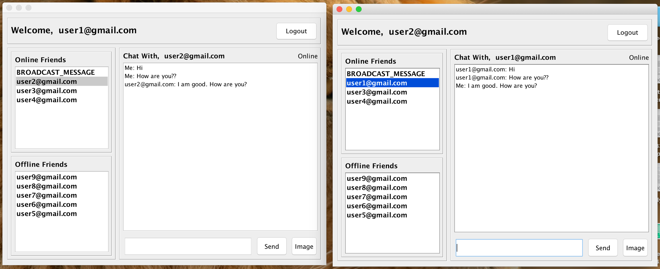

**8. Broadcast Message by User1**

When User1 sends a Broadcast Message, it is sent to all the Users directly

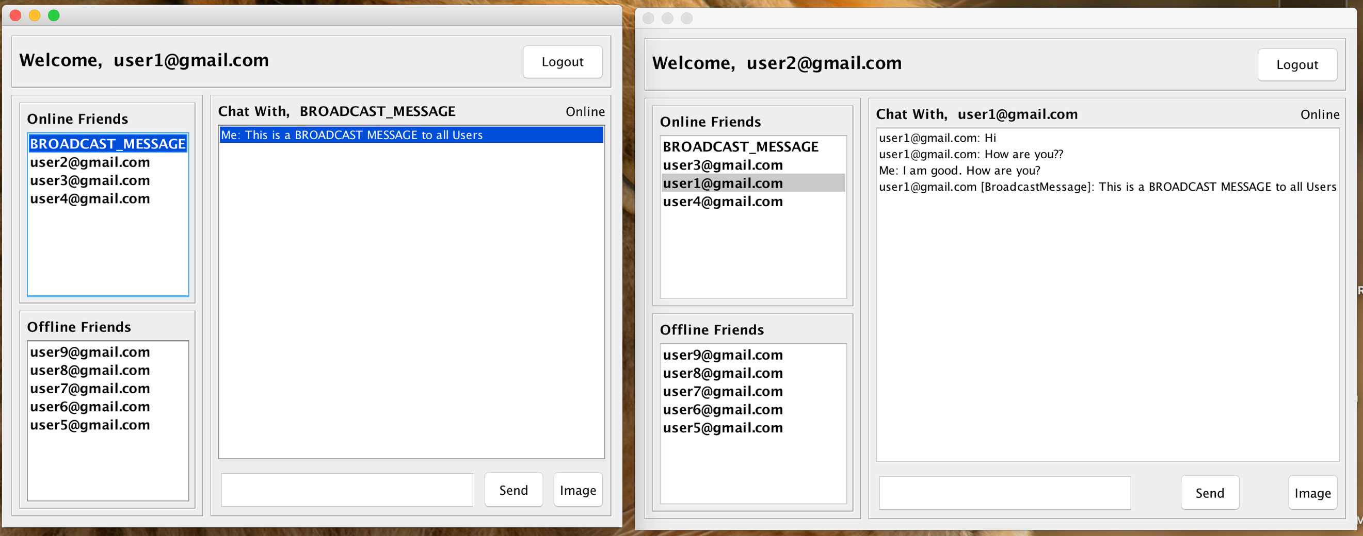

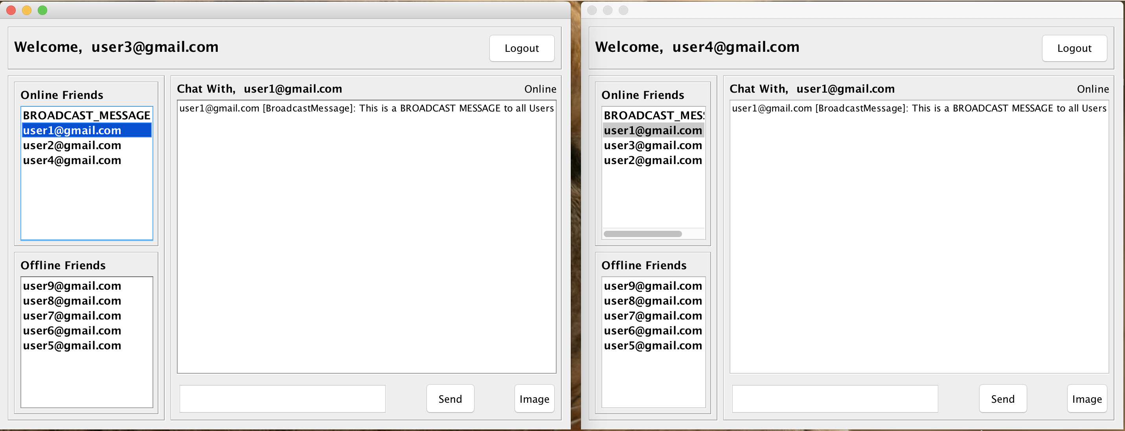

**9. Personal Chat Multimedia Message (Image File)**

When User1 wants to send a multimedia message, they click on the Image button, while opens the System File Dialog Box to choose a image file to be sent to other user.

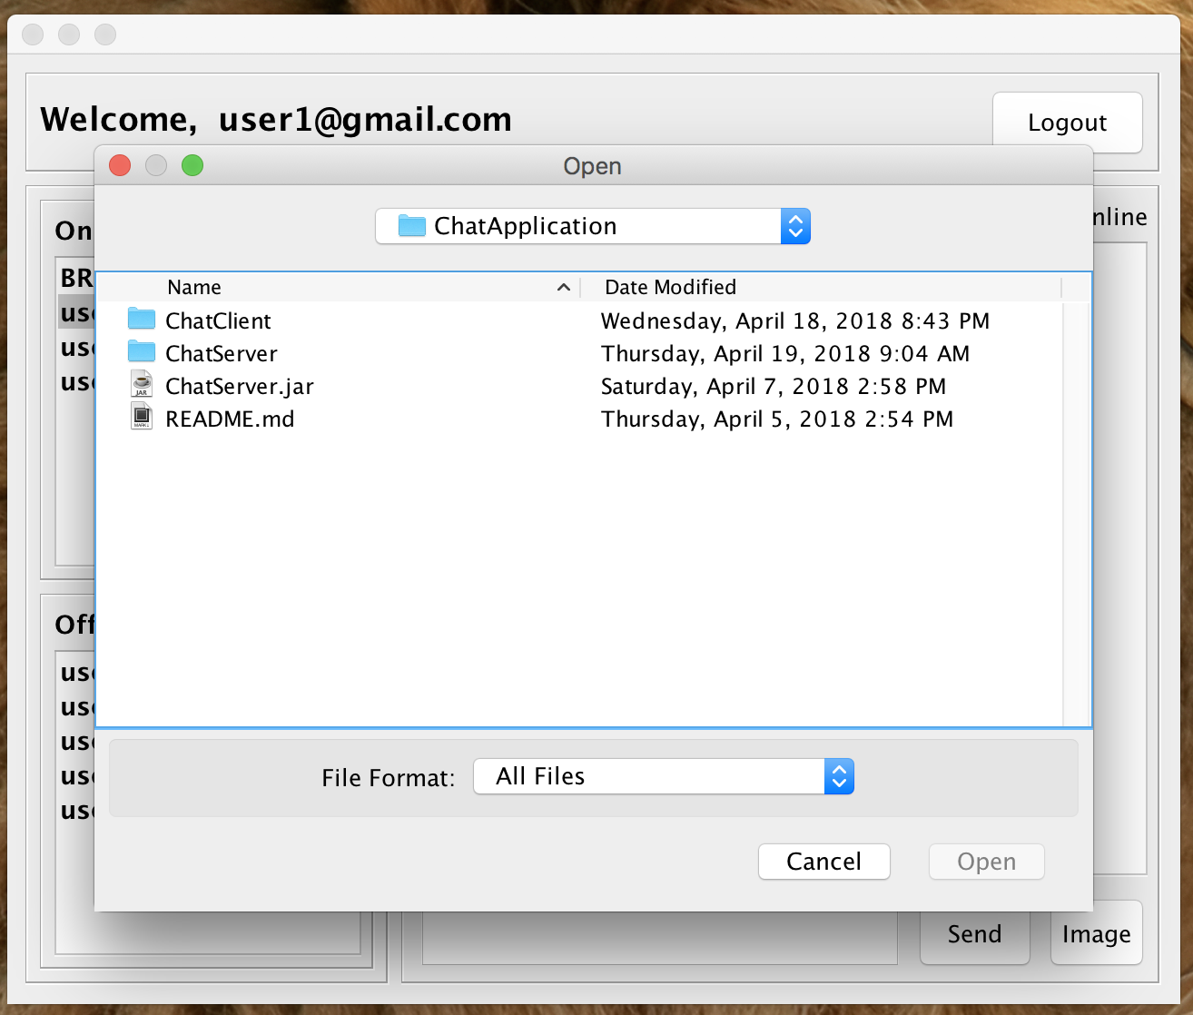

**10. Personal Chat Multimedia Message (Image File)**

User1 sends an Image File to User2

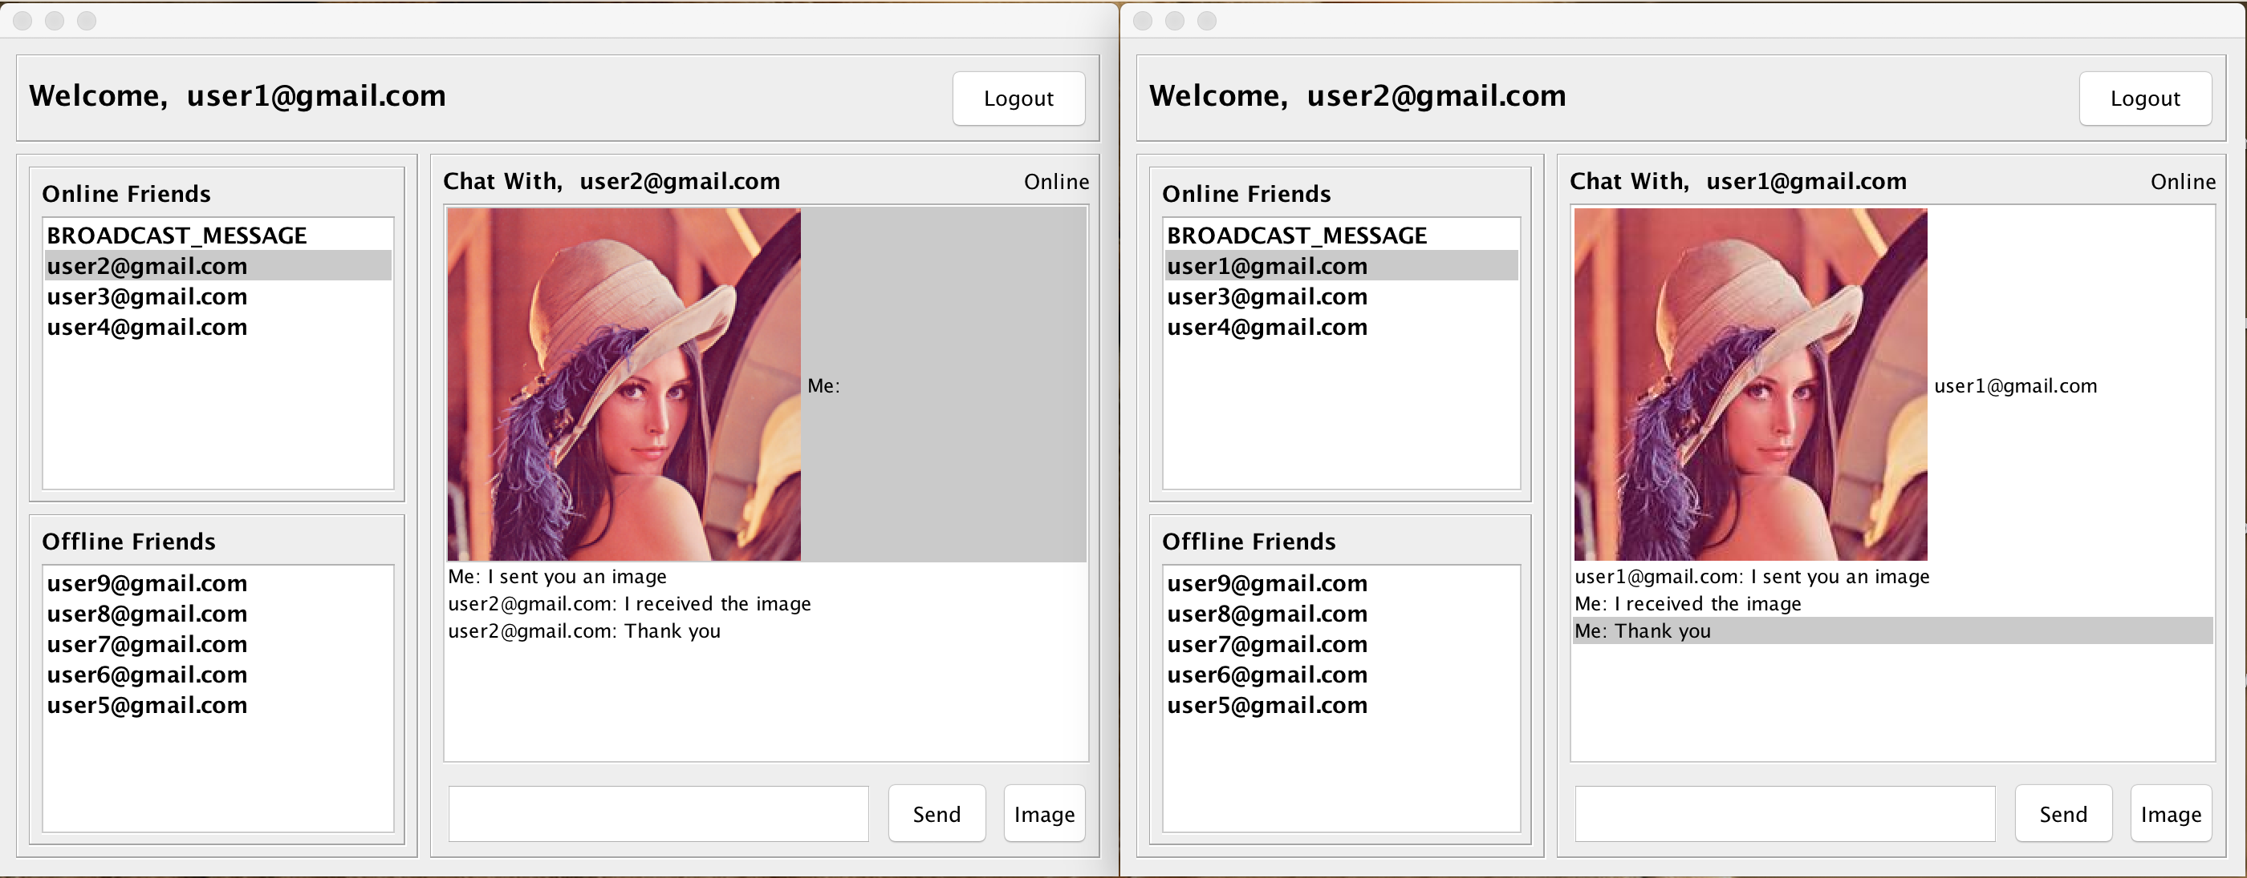

**11. Last Seen of the OFFLINE users**

We can see the last seen of the OFFLINE users, when were they last connected to the server.

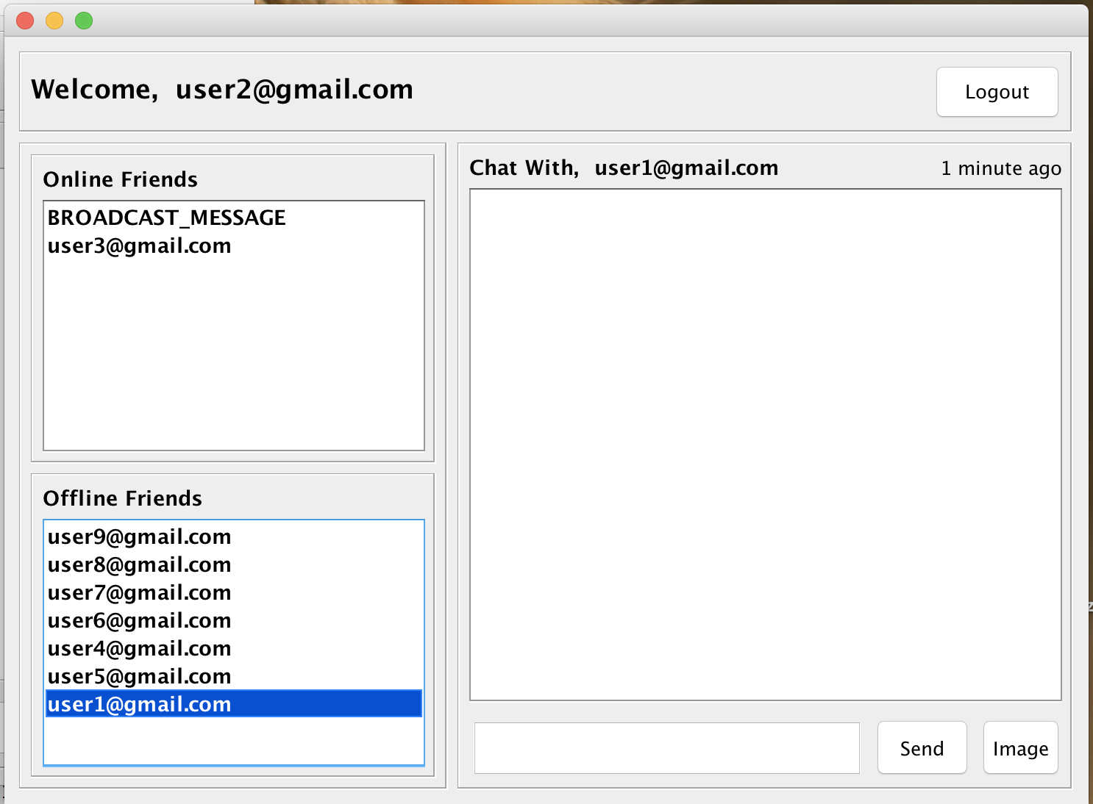

**12. The Login Signup and the Chat Screen UI is made with Java Swing in Net Beans**

All the UI is made with Java Swing, which was helpful to bridge the UI with the backend.

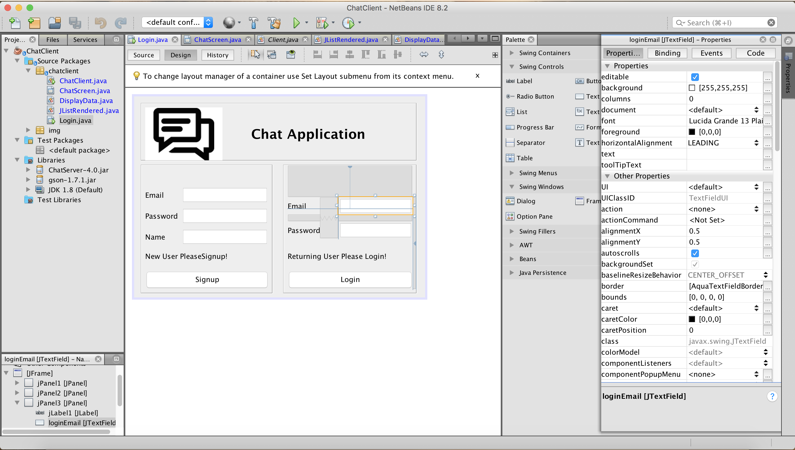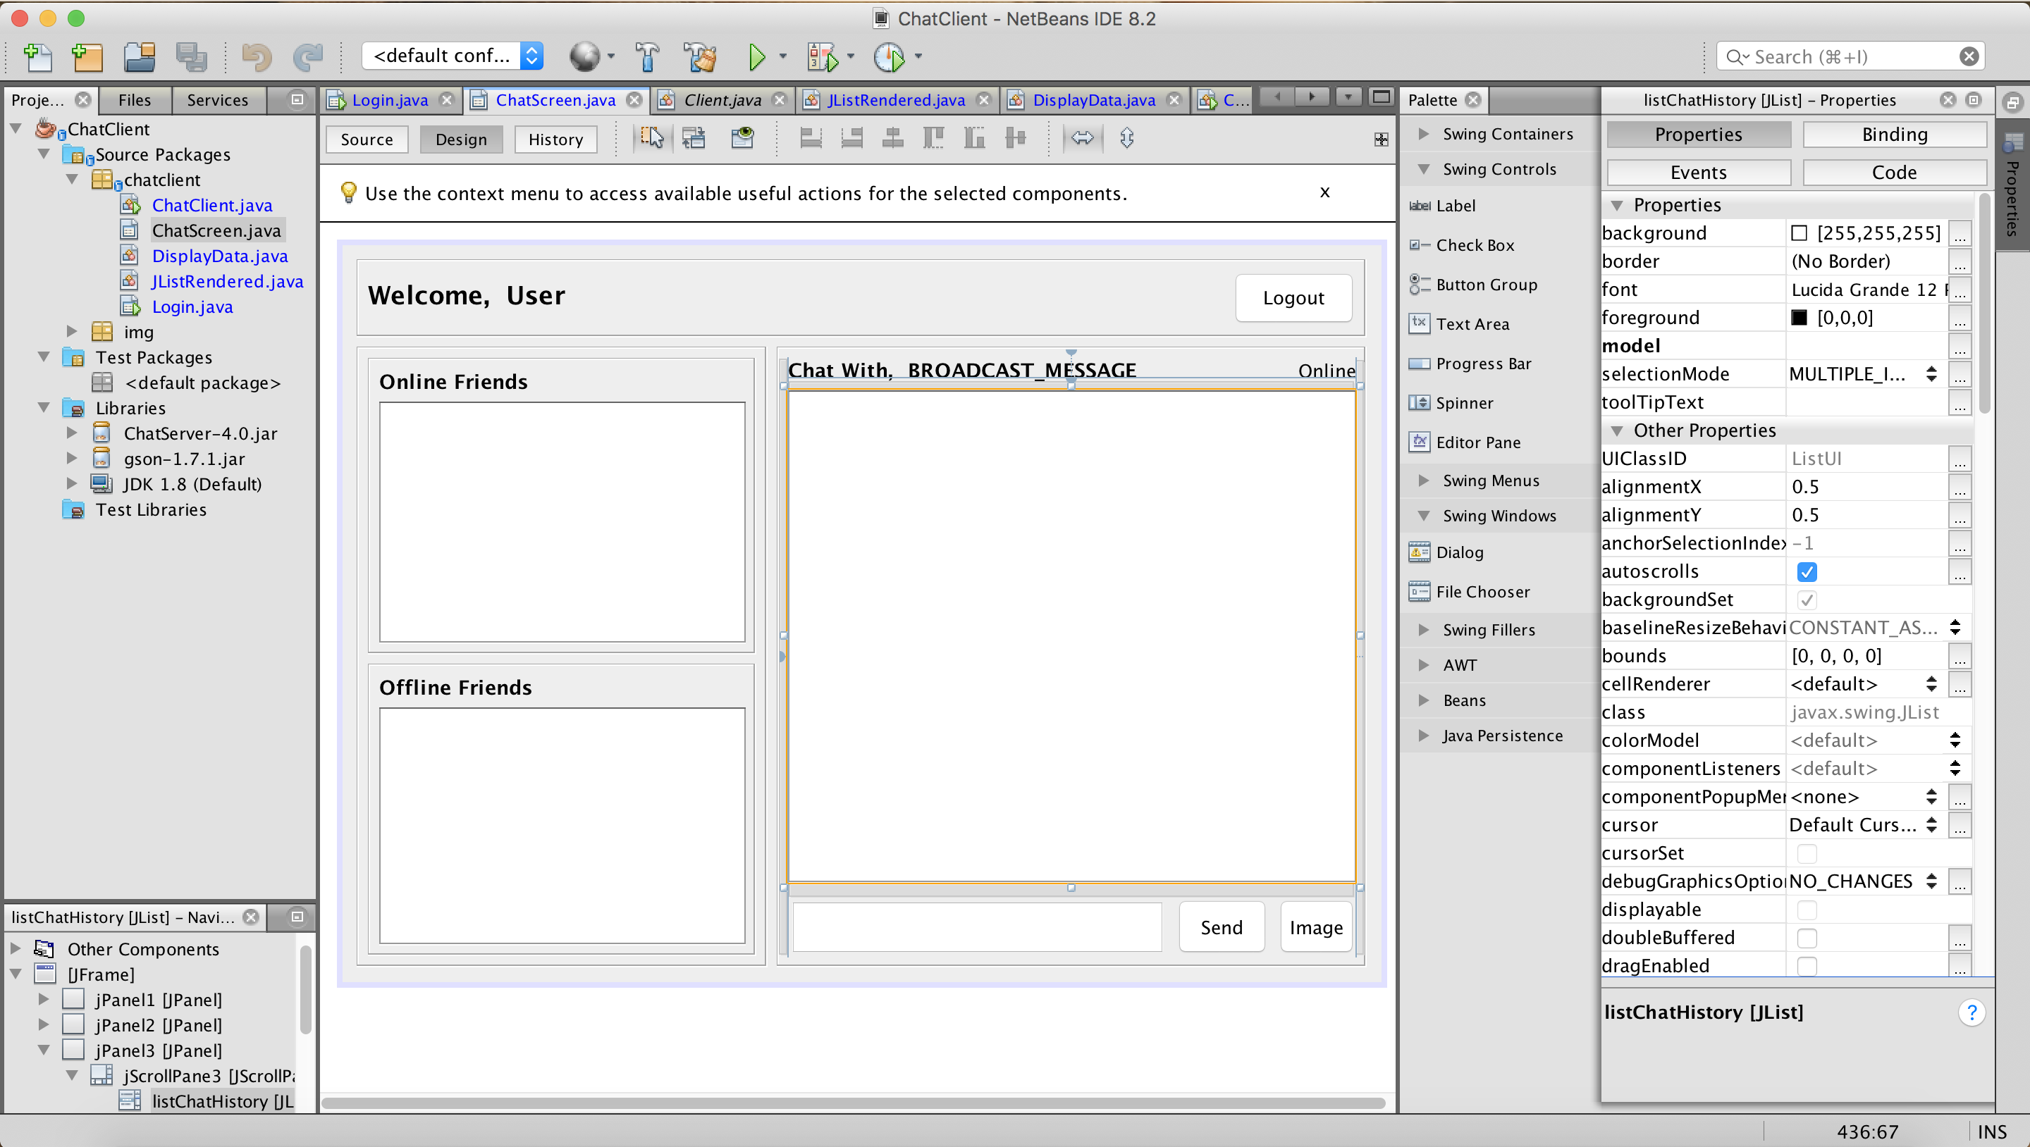

**Screen Shot of the Package Structure**

**1. Chat Application Package Structure in Eclipse**

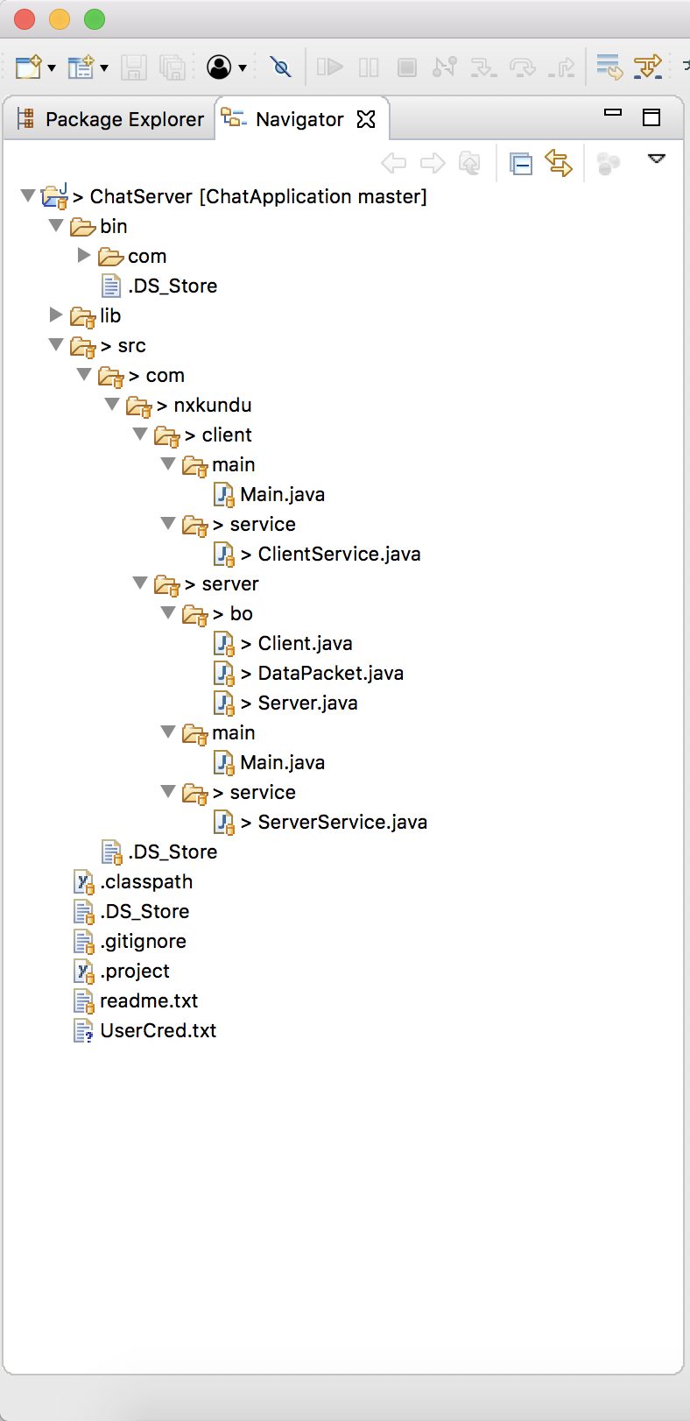

**2. Chat UI Package Structure in Net Beans**

